Name:  Teacher : | ____________________________________  ______________________ |  | Date:_________
 | Year 12 Essentials  Area and Volume investigation - Validation  Full working out MUST be shown to get full marks for each question.
Total Time: | 55 minutes
Weighting: | 5%
Equipment: | To be provided by the student: Pen, pencil, ruler, scientific calculator, INVESTIGATION PART 1
/27
Farmer Kath has chosen to build the chicken coup below. Find the total surface area of the newly designed chicken coup. [9 Marks]
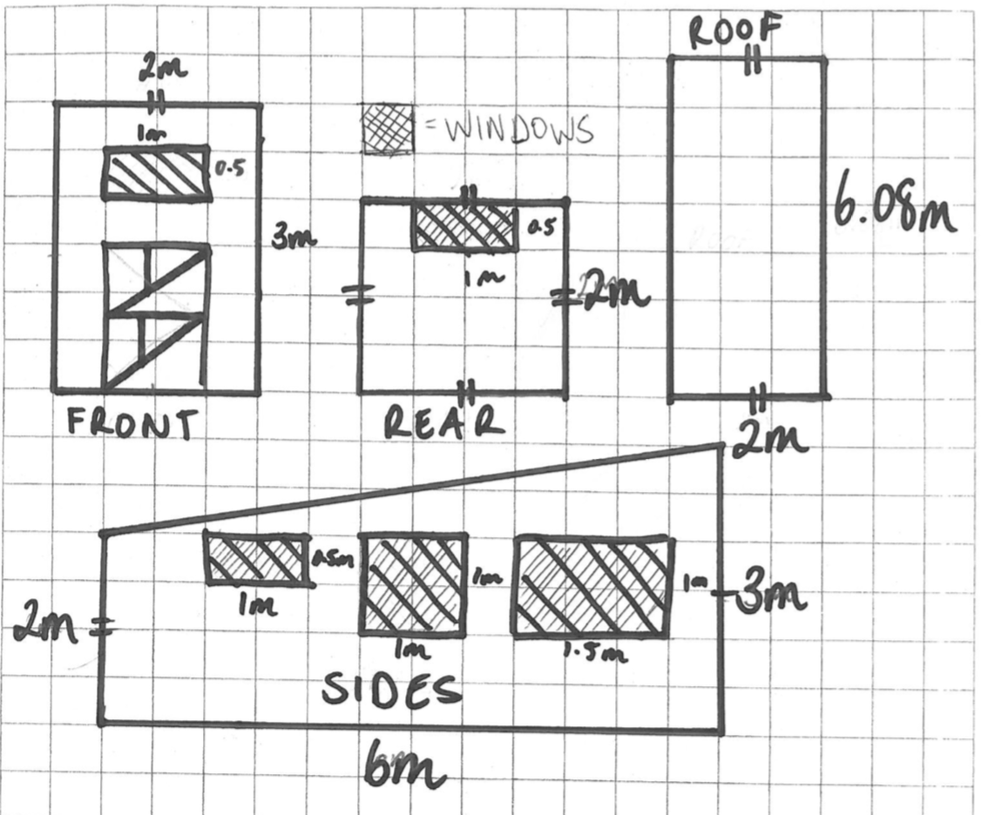

If she was going to build this coup, and paint it, how much would it cost to build in total? [7 Marks]

She uses her fencing to build a U-Shaped field. Find the total Area of the field. [3 Marks]

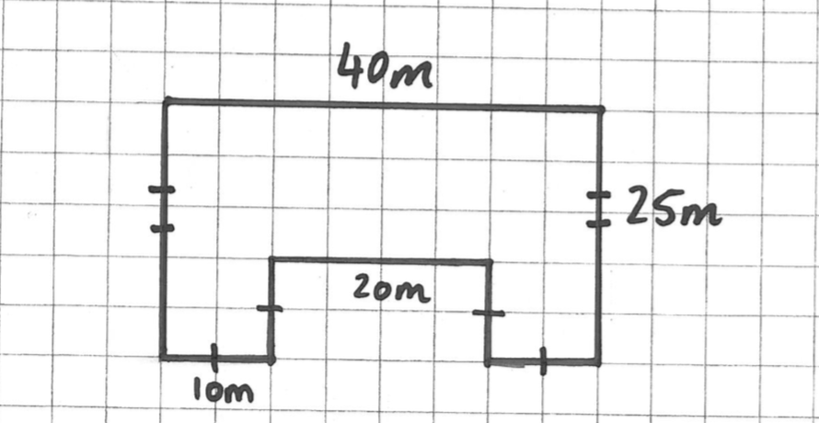

Farmer Kath decides she needs to be able to store more water. She has two options:
- Replace her old tanks with two new tanks that are 10m wide and 6m tall

- Or purchase one additional tank the same as the other three.

Which option gives her the most amount of water? [7 Marks]

END OF ASESSMENT

